In this userguide, we will demonstrate how to register your website in a few simple steps! Your financial representative will send a system generated email with an embedded registration link. For your security, this link has redemption codes built into it. This means that the link you received is one time only use. Once the link has been clicked on, it will then expire. Make sure not to click the link until you are fully ready to complete the registration process! Registration should take no more than 10 minutes.

Please Note: The registration invitation email expires 7 days from initial receipt. If you delete the email, your financial representative will be able to resend it.

- From your email, open the invitation email.
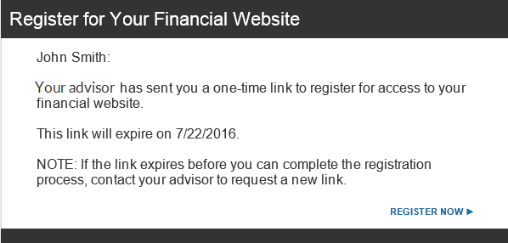
- The link will open a new page in your default internet browser. Here you will establish a unique Username & Password. Follow the password meter to confirm you have met the security requirements.
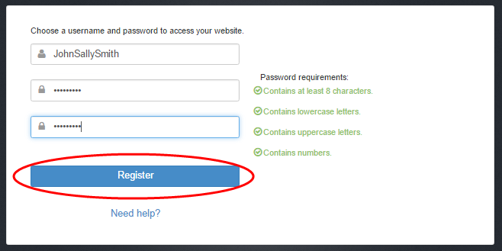
- Next, you will be prompted to answer 3 security questions.
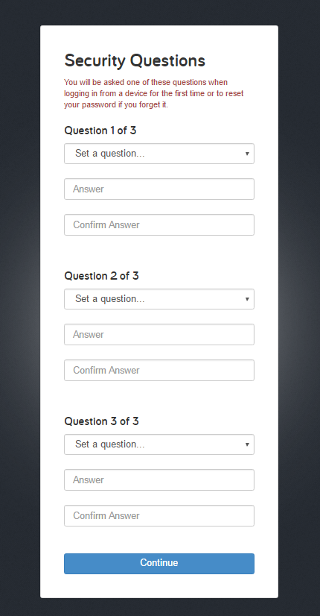

- Finally, read and accept the Terms of Service.
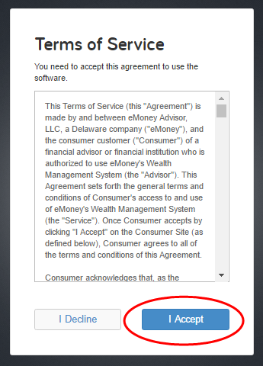
- Once you have successfully registered for your website, you will receive a confirmation email as shown below. Save the log on link to your bookmarks for easy access!
