This training guide will walk you through utilizing the spending & budgeting tools available in your financial portal.

These tools allow you to build out monthly spending budgets while also tracking spending habits on your connected transactional accounts.

To analyze spending and budgeting, you must first connect your accounts. Please refer to the Adding Accounts user guide for additional information.

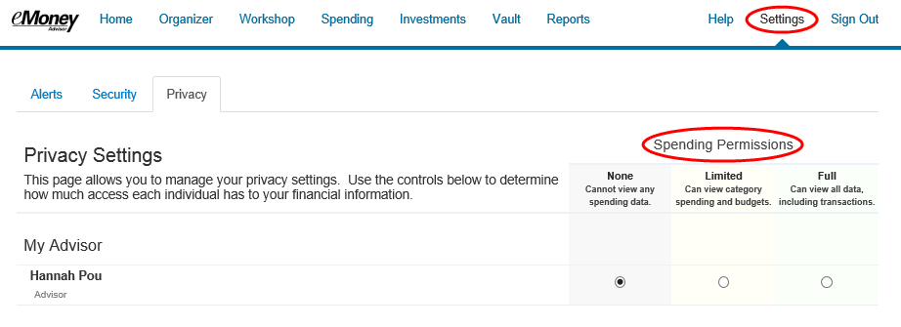
Please Note: By default, your advisor will be unable to see your spending information. To change this setting, modify your privacy permissions located in settings.

- From the Home page, click the Spending tab or tile.
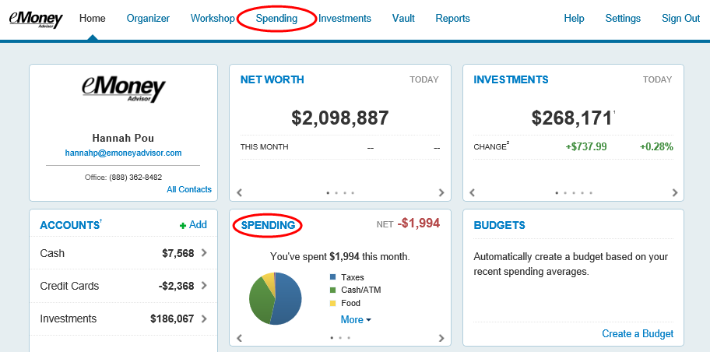
- The Spending page is comprised of 3 sections: Overview, Budgets, and Transactions.
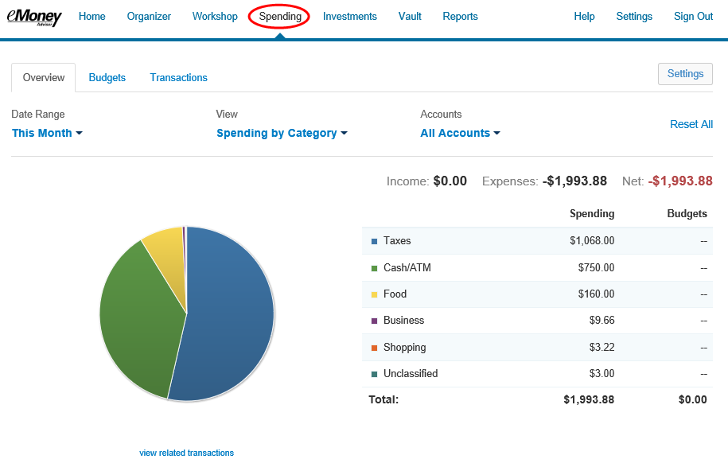

- The Overview tab shows spending by category over a specific date range. The default view is to view spending amounts This Month, by Category, and from All Accounts. Hover over the pie chart to see how much you’ve spent in that category. You can also click “view related transactions” to see a list of transactions from the specified date range and accounts.
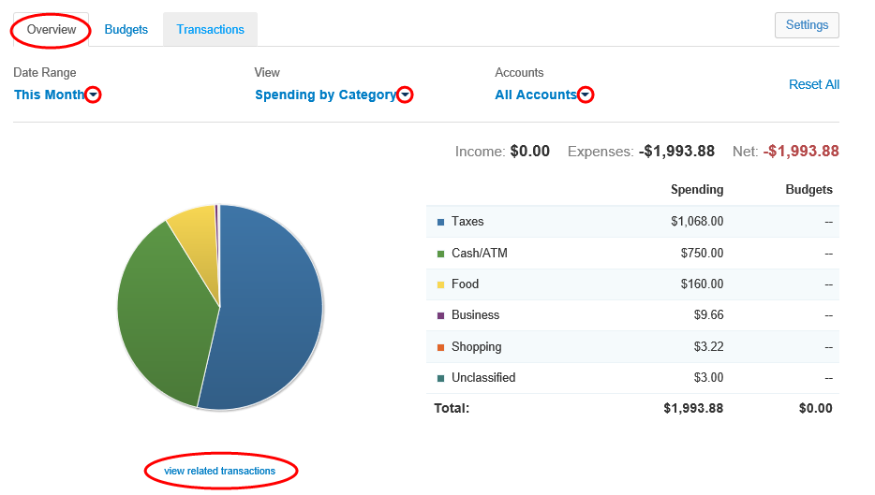

- The Budgets tab allows you to create budgets to help manage your expenses. You can either add budget items one at a time by category, or you can select Create an Auto-Budget to view a budget created automatically based on your average spending from the past six months.
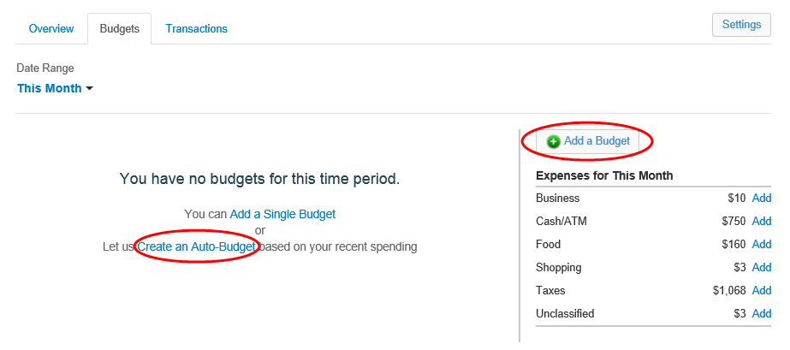
- Once you've added your budget, go back to the Spending - Overview tab and select the Budget History view to see the amount you've budgeted, the amount you've spent, and whether you're over or under budget.
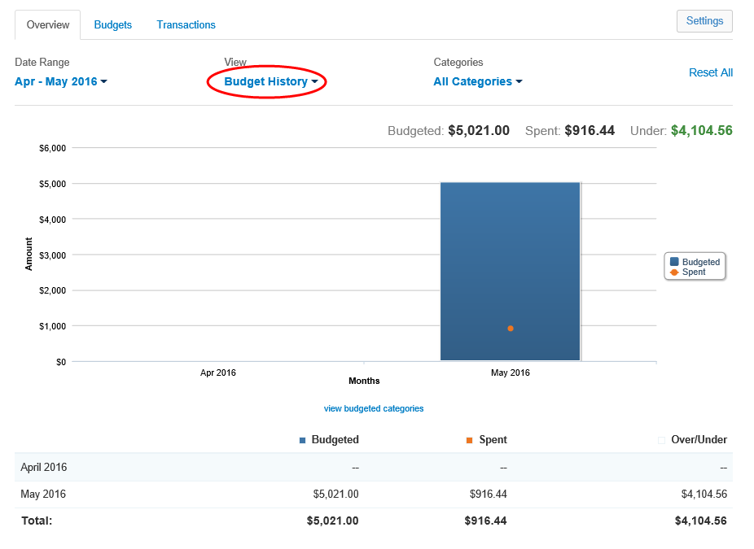

- The Transactions tab displays all bank transactions from your online accounts. The number of transactions found and the total amount will be displayed at the top of your transactions list.
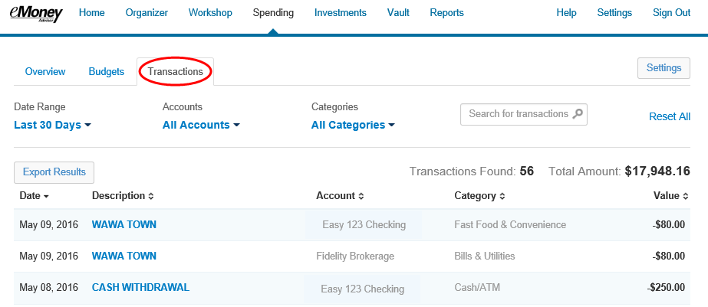
To make changes to the Description or Category provided for transaction, click the transaction's row and type a new description and/or select a new category from the drop-down.
If you want to apply your edits to all similar transactions, you can create a rule. Make the edits to the Description and Category of a transaction. Click Details below the transaction row.
Click the checkbox before the rule, and then click Advanced to apply a monetary or date range to the rule using the entry boxes provided. Click Done
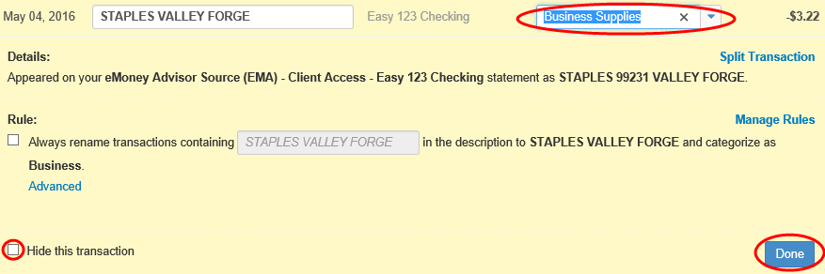

- If you can't find the category you're looking for, you can create new subcategories by clicking settings at the top of the budgeting page. Choose the parent category, type in new sub category and click Add.
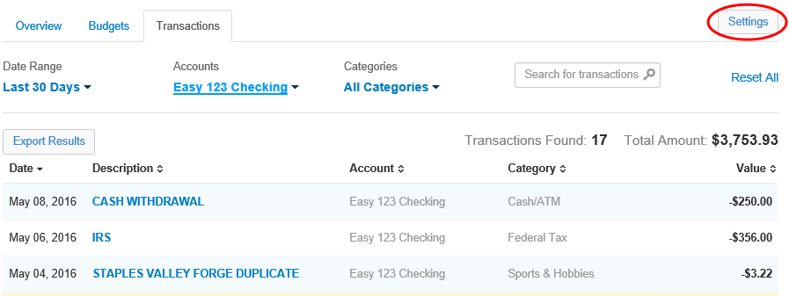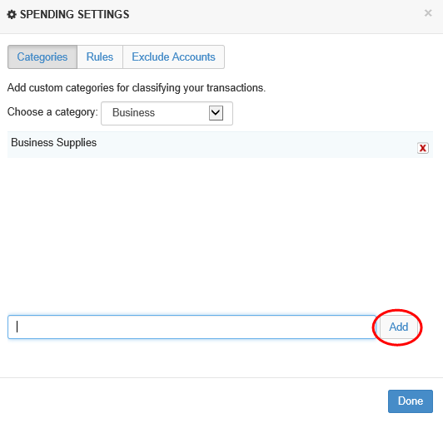

- To Export transactions, click the Export Results button to export the transaction table to a .CSV format.
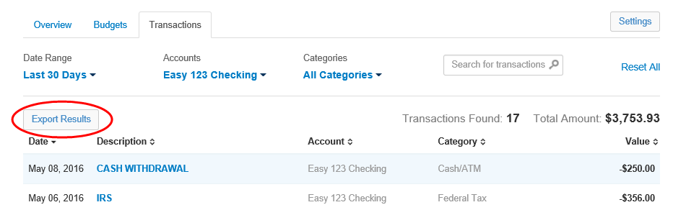

- The Settings button allows you to further manage spending Categories, Rules, and Excluded Accounts.
